#1

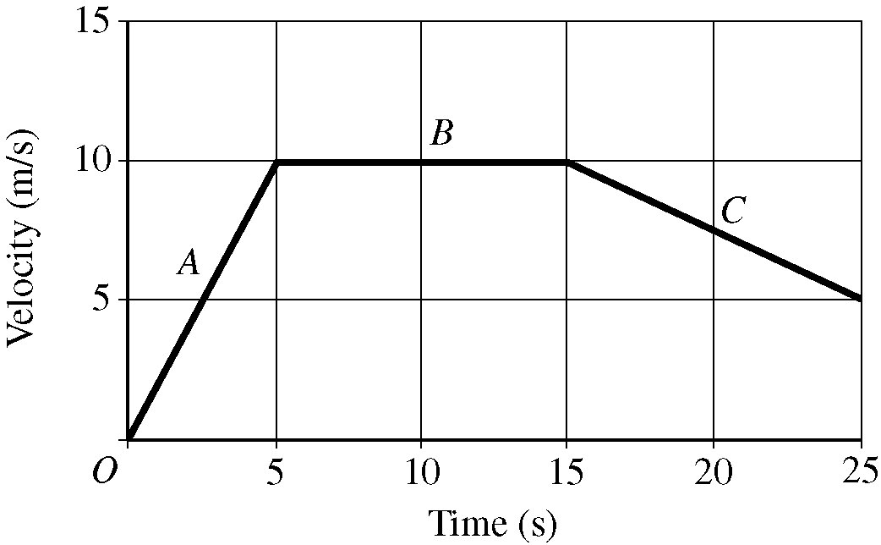
A 0.40 kg object moves in a straight line under the action of a net force. The graph above shows the velocity as a function of time for the object during a 25 s interval. At time t = 0, the object is at the position x = 0.
(a) On the grid below, sketch a graph of the acceleration as a function of time for the object. Label the scale for the acceleration.

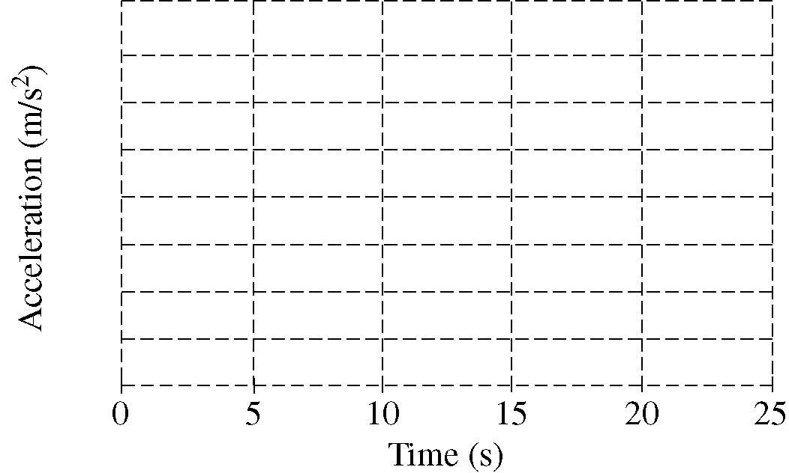
(b) Calculate the position of the object at t = 5.0 s.
(c) On which segment of the graph is the net force acting on the object zero?
_ ___ A ____ B ____ C
Justify your answer.
(d) Calculate the net force on the object during the first 3.0 s of the motion.

#2

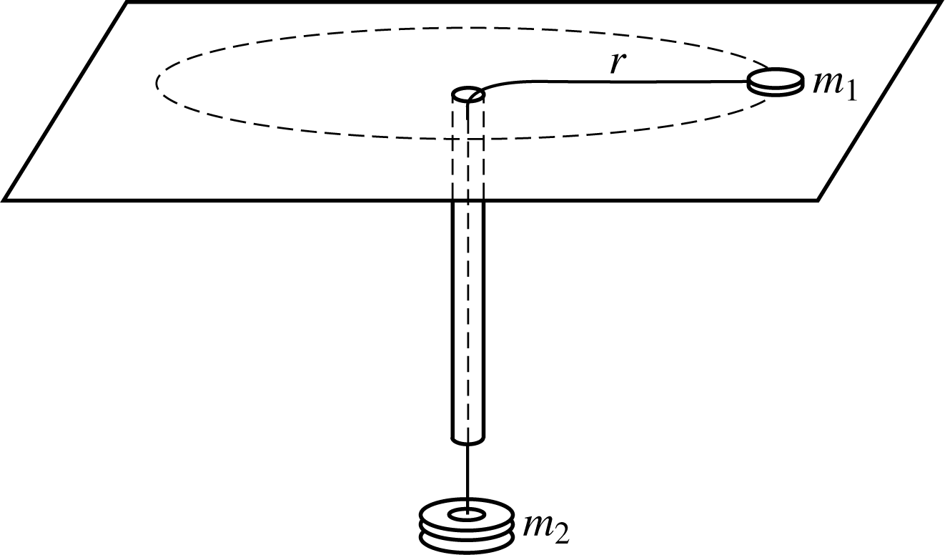
An experiment is performed using the apparatus above. A small disk of mass m1 on a frictionless table is attached to one end of a string. The string passes through a hole in the table and an attached narrow, vertical plastic tube. An object of mass m2 is hung at the other end of the string. A student holding the tube makes the disk rotate in a circle of constant radius r, while another student measures the period P.
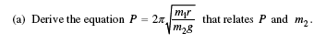
The procedure is repeated, and the period P is determined for four different values of m2 , where
m1 = 0.012 kg and r = 0.80 m. The data, which are presented below, can be used to compute an experimental value for g.
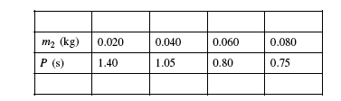
(b) What quantities should be graphed to yield a straight line with a slope that could be used to determine g?
(c) On the grid below, plot the quantities determined in part (b), label the axes, and draw the best-fit line to the data. You may use the blank rows above to record any values you may need to calculate.
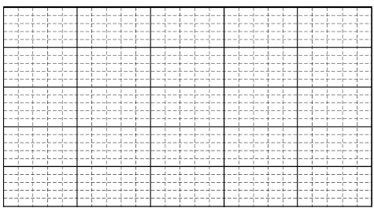
(d) Use your graph to calculate the experimental value of

#3
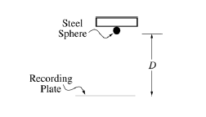
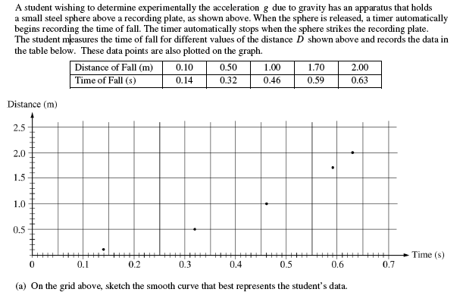
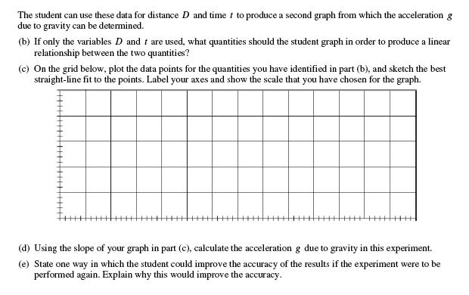

#4
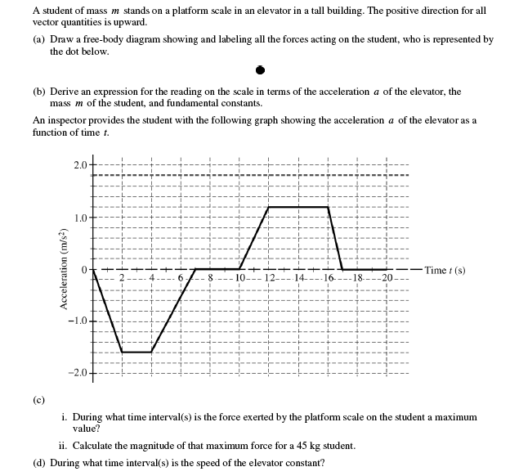

#5
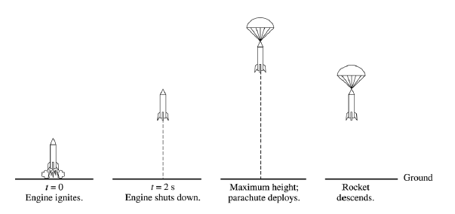
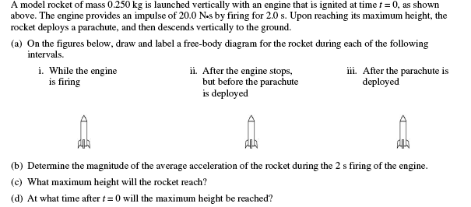

#6
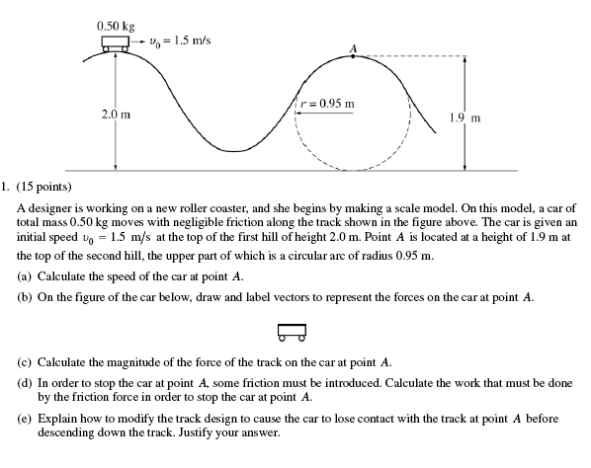

#7
